Regional Operational Plan DF.#R.YY-XX

Operational Plan: Threemile Lake Invasive Northern Pike Population Assessment

by

Kristine Dunker, Parker Bradley, and Cody Jacobson

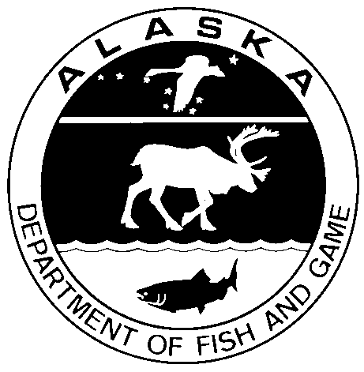

March 2018

Alaska Department of Fish and Game Divisions of Sport Fish and Commercial Fisheries

Symbols and Abbreviations

The following symbols and abbreviations, and others approved for the Système International d'Unités (SI), are used without definition in the following reports by the Divisions of Sport Fish and of Commercial Fisheries: Fishery Manuscripts, Fishery Data Series Reports, Fishery Management Reports, and Special Publications. All others, including deviations from definitions listed below, are noted in the text at first mention, as well as in the titles or footnotes of tables, and in figure or figure captions.

**Weights and measures (metric)**

centimeter cm

deciliter dL

gram g

hectare ha

kilogram kg

kilometer km

liter L

meter m

milliliter mL

millimeter mm

**Weights and measures (English)**

cubic feet per second ft3/s

foot ft

gallon gal

inch in

mile mi

nautical mile nmi

ounce oz

pound lb

quart qt

yard yd

**Time and temperature**

day d

degrees Celsius °C

degrees Fahrenheit °F

degrees kelvin K

hour h

minute min

second s

**Physics and chemistry**

all atomic symbols

alternating current AC

ampere A

calorie cal

direct current DC

hertz Hz

horsepower hp

hydrogen ion activity pH

(negative log of)

parts per million ppm

parts per thousand ppt,

‰

volts V

watts W

**General**

Alaska Administrative

Code AAC

all commonly accepted

abbreviations e.g., Mr., Mrs., AM, PM, etc.

all commonly accepted

professional titles e.g., Dr., Ph.D.,

R.N., etc.

at @

compass directions:

east E

north N

south S

west W

copyright ©

corporate suffixes:

Company Co.

Corporation Corp.

Incorporated Inc.

Limited Ltd.

District of Columbia D.C.

et alii (and others) et al.

et cetera (and so forth) etc.

exempli gratia

(for example) e.g.

Federal Information

Code FIC

id est (that is) i.e.

latitude or longitude lat. or long.

monetary symbols

(U.S.) $, ¢

months (tables and

figures): first three

letters Jan,...,Dec

registered trademark ®

trademark ™

United States

(adjective) U.S.

United States of

America (noun) USA

U.S.C. United States Code

U.S. state use two-letter abbreviations (e.g., AK, WA)

**Mathematics, statistics**

*all standard mathematical*

*signs, symbols and*

*abbreviations*

alternate hypothesis HA

base of natural logarithm *e*

catch per unit effort CPUE

coefficient of variation CV

common test statistics (F, t, χ2, etc.)

confidence interval CI

correlation coefficient

(multiple) R

correlation coefficient

(simple) r

covariance cov

degree (angular ) °

degrees of freedom df

expected value *E*

greater than >

greater than or equal to ≥

harvest per unit effort HPUE

less than <

less than or equal to ≤

logarithm (natural) ln

logarithm (base 10) log

logarithm (specify base) log2, etc.

minute (angular) '

not significant NS

null hypothesis HO

percent %

probability P

probability of a type I error

(rejection of the null

hypothesis when true) α

probability of a type II error

(acceptance of the null

hypothesis when false) β

second (angular) "

standard deviation SD

standard error SE

variance

population Var

sample var

Regional Operational plan DF.#R.YY-XX

**Threemile Lake Invasive Northern pike population assessment**

by

Kristine Dunker, Parker Bradley and Cody Jacobson

Alaska Department of Fish and Game, Division of Sport Fish, Anchorage

Alaska Department of Fish and Game  
Division of Sport Fish

March 2018

The Regional Operational Plan Series was established in 2012 to archive and provide public access to operational plans for fisheries projects of the Divisions of Commercial Fisheries and Sport Fish, as per joint-divisional Operational Planning Policy. Documents in this series are planning documents that may contain raw data, preliminary data analyses and results, and describe operational aspects of fisheries projects that may not actually be implemented. All documents in this series are subject to a technical review process and receive varying degrees of regional, divisional, and biometric approval, but do not generally receive editorial review. Results from the implementation of the operational plan described in this series may be subsequently finalized and published in a different department reporting series or in the formal literature. Please contact the author if you have any questions regarding the information provided in this plan. Regional Operational Plans are available on the Internet at: <http://www.adfg.alaska.gov/sf/publications/>

Kristine Dunker, Parker Bradley and Cody Jacobson

Alaska Department of Fish and Game, Division of Sport Fish,

333 Raspberry Road,

Anchorage, AK

99518-1565

This document should be cited as:

Dunker, K, P. Bradley and C. Jacobson. 2018. Threemile Lake Invasive Northern Pike Population Assessment. Alaska Department of Fish and Game, Regional Operational Plan ROP.DF#R.YY-XX, Anchorage.

The Alaska Department of Fish and Game (ADF&G) administers all programs and activities free from discrimination based on race, color, national origin, age, sex, religion, marital status, pregnancy, parenthood, or disability. The department administers all programs and activities in compliance with Title VI of the Civil Rights Act of 1964, Section 504 of the Rehabilitation Act of 1973, Title II of the Americans with Disabilities Act (ADA) of 1990, the Age Discrimination Act of 1975, and Title IX of the Education Amendments of 1972.

**If you believe you have been discriminated against in any program, activity, or facility please write:**

ADF&G ADA Coordinator, P.O. Box 115526, Juneau, AK 99811-5526

U.S. Fish and Wildlife Service, 4401 N. Fairfax Drive, MS 2042, Arlington, VA 22203

Office of Equal Opportunity, U.S. Department of the Interior, 1849 C Street NW MS 5230, Washington DC 20240

**The department’s ADA Coordinator can be reached via phone at the following numbers:**

(VOICE) 907-465-6077, (Statewide Telecommunication Device for the Deaf) 1-800-478-3648,

(Juneau TDD) 907-465-3646, or (FAX) 907-465-6078

**For information on alternative formats and questions on this publication, please contact:**

ADF&G, Division of Sport Fish, Research and Technical Services, 333 Raspberry Rd, Anchorage AK 99518 (907) 267-2375

Signature Page

|  |  |
| --- | --- |
| Project Title: | Threemile Lake Invasive Northern Pike Population Assessment |
| Project leader(s): | Kristine Dunker, Parker Bradley and Cody Jacobson |
| Division, Region, and Area | Division of Sport Fish, Region II, Palmer Office |
| Project Nomenclature: | Northern pike, Invasive species, Threemile Lake, Population Assessment, Mark-Recapture |
| Period Covered | May 2018 through August 2018 |
| Field Dates: | June 1-30, 2018 |
| Plan Type: | Category II |

**Approval**

|  |  |  |  |  |  |  |
| --- | --- | --- | --- | --- | --- | --- |
| Title |  | Name |  | Signature |  | Date |
| Project co- leader |  | Kristine Dunker |  |  |  |  |
| Project co-leader |  | Parker Bradley |  |  |  |  |
| Biometrician |  | Ben Buzzee |  |  |  |  |
| Research Coordinator |  | Tim McKinley |  |  |  |  |

TABLE OF CONTENTS

Page

LIST OF Tables 27

LIST OF FIGURES 27

LIST OF APPENDICES 27

INTRODUCTION 28

Objectives 30

Study Area 30

Methods 33

Background 33

Study Design 34

Threemile Lake Northern Pike Population Estimate 34

Evaluation of Assumptions 36

Upper Lilly Pad Lake Northern Pike Survey 37

Data Collection38

Threemile Lake Northern Pike Population Estimate 38

Pike Population Characteristics 39

Upper Lily Pad Lake Northern Pike Survey 39

Data Reduction 39

Data Analysis 39

Threemile Lake Northern Pike Population Estimate 39

Upper Lily Pad Lake Northern Pike Survey 40

Schedule and Deliverables 40

Literature Cited 43

APPENDICES 44

# LIST OF Tables

Table 1. Probability of Non-Detection of Pike in Upper Lily Pad Lake 12

# LIST OF FIGURES

Figure 1. Native and Invasive Range of Northern Pike in Alaska 3

Figure 2. Map of the Tyonek Area Watershed 31

Figure 3. Map of the Threemile Creek Drainage 32

Figure 4. Map of the Threemile Lake Complex 33

# LIST OF APPENDICES

Appendix 1. Photograph of Threemile Lake 44

Appendix 2. Photograph of Upper Lily Pad Lake 44

Appendix 3. Probability of Non-Detection Description 45

Appendix 4. Tests of Consistency for Petersen Estimator 48

Appendix 5. Data Sheets 53

# INTRODUCTION

The northern pike (*Esox Lucius*) is an invasive species in Southcentral Alaska that is steadily devastating salmonid populations through juvenile salmon predation in invaded waters (ADF&G 2007). The effects of this are most severe in shallow, slow moving, vegetated lakes and streams where pike and rearing salmonids share complete habitat overlap (Sepulveda et al. 2013 and 2014). Northern pike are native throughout much of the state but do not naturally occur south and east of the Alaska Range (Figure 1). They were introduced by anglers to the Yentna River drainage in the late 1950’s and subsequently spread throughout the Susitna River basin through flood events and further illegal stockings (Mills 1986). Today pike have been documented from over 120 lakes and rivers in Southcentral Alaska.

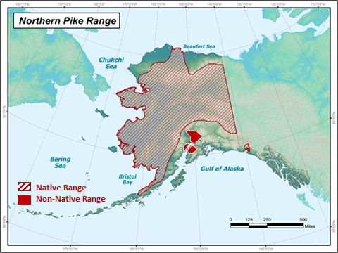

**Figure 1. Northern pike range in Alaska.**

More recently, smaller-scale “secondary” pike infestations (ex. originating from the Susitna infestation) have been reported widely throughout small, costal-run stream systems throughout Cook Inlets’ western coast (herein referred to as West Cook Inlet). West Cook Inlet is off the road system, sparsely populated and home to hundreds of small, complex, salmon-producing stream systems. Many reports of pike presence have come from sport and subsistence anglers; however, most reports lack live or dead specimens, preventing conclusive knowledge of the extent of infestation.

One area where pike are well-established and salmon populations have been affected is the Threemile Creek drainage on the Western side of Cook Inlet between the communities of Beluga and the Native Village of Tyonek. The Tyonek Tribal Conservation District (TTCD) has identified the Threemile Creek drainage as the most significant watershed in the area where pike are adversely affecting salmon.

The Native Village of Tyonek (NVT) is a Dena’ina Athabascan village located 43 miles southwest of Anchorage, along the Cook Inlet, and is home to approximately 200 people. There are no roads to Tyonek which necessitate access via boat or small aircraft. The remote setting and cultural heritage of NVT makes subsistence activities of paramount importance with many of these activities focused on salmon. The total subsistence harvest for Tyonek in 2013 was 16,766 total pounds of salmon or 118 pounds per capita (Jones et al 2015). Although Threemile Creek is located about 3 miles north of Tyonek, pike in that system are suspected of reducing salmon populations in Threemile Creek, and therefore, decreasing the number of salmon returning along the West Cook Inlet beaches where Tyonek’s subsistence fishing occurs. Also, with pike thriving in the Threemile drainage without established containment or control, their potential to continue spreading into surrounding waterbodies in and around Tyonek and into vulnerable drainages along the West Side of Cook Inlet remains high without management intervention.

Initial pike assessments in the West Side Cook Inlet drainages between 2015 and 2017 (Swenson and Hagan 2017) documented pike from several area waters (Threemile Lake, Chuit Lake, and Second Lake), though much uncertainty remains regarding overall pike distribution in the region. Survey data collected to date suggest the Threemile drainage has been the most severely affected of the surveyed waters. This area yielded the greatest CPUE of pike with no other species of fish captured or observed, which is often the case in waters where pike have a significant ecological impact (Dunker et al. 2018). The area of the drainage where most of the pike impacts are thought to be centered is the Threemile Lake Complex which consists of East and West Threemile Lake and Lower Lily Pad Lake. This lake Complex is a strong candidate for annual invasive northern pike suppression, similar to ongoing efforts in Alexander Creek (Rutz and Dunker 2016). Initiating an effort like this could directly benefit salmon populations and both subsistence and sport fisheries in the Tyonek region. Most importantly, management of this invasive pike population might also hinder expansion of pike to other vulnerable drainages along West Cook Inlet. Before initiating an annual pike suppression program in the Threemile Lake Complex, an initial assessment of the population is prudent to facilitate future evaluation of the suppression program. In this project, ADF&G, in partnership with the TTCD and the Cook Inlet Aquaculture Association (CIAA), will attempt to estimate the population size of pike in the Threemile Lake Complex, assess specific pike population characteristics (i.e. size, sex, diet, age), and begin surveys of upstream waters in the drainage.

The mission of ADF&G’s Sport Fish Division is “to protect and improve the state’s recreational fisheries resources”, and an objective of the Division’s strategic plan is to “minimize impacts of invasive species on fish stocks, recreational fisheries, and fish habitat”. Removing northern pike from vital salmon rearing habitat directly relates to this objective. ADF&G has an aquatic nuisance species management plan (ADF&G 2002) and an invasive northern pike management plan (ADF&G 2007). Goals and objectives in these plans address the need to remove invasive northern pike where possible and improve salmon populations that have been impacted by northern pike. The activities proposed in this project are aligned with several plans and initiatives, and ADF&G believes this project will provide the first step in a long-term initiative to effectively suppress the invasive northern pike population in the Threemile Drainage.

# Objectives

This project will lay the foundation from which a long-term pike suppression program can be effectively designed and evaluated by estimating the population size of northern pike in the Threemile Lake Complex and surveying a lake directly upstream to confirm pike distribution. Objectives for the suppression program will be addressed in a separate operational plan for that effort. Specific objectives for this current project include:

1. Estimate the population size of northern pike > 300 mm fork length (FL) in the Threemile Lake Complex such that the estimate is within 25% of the true population size 90% of the time.

**Secondary Objectives:**

1. Detect the presence of northern pike in Upper Lily Pad Lake such that the probability of detection is greater than 95% given the population is at least 4 northern pike.
2. Calculate the mean length (FL) and length range of northern pike in the Threemile Lake Complex.
3. Document stomach contents, sex, and age of northern pike in the Threemile Lake Complex.

# Study Area

This project will take place in the Tyonek Tribal Conservation District (TTCD). The TTCD shares its boundaries with Alaska Game Management Unit 16B. The District’s eastern edge is the Susitna River, its northern and western boundaries are the divide of the Alaska Range, and its southern border is Cook Inlet. Population and infrastructure in the region is limited but is centered on the Tyonek-Beluga corridor. The Tyonek-Beluga corridor hosts a population of roughly 200 people, hosts over 80 miles of unimproved roads and has 3 airstrips. Waterbodies in proximity to this small population corridor are classified as the Tyonek Area Watershed (Figure 2). The Watershed has 378 lakes and approximately 1,624 river miles of freshwater and is home to all 5 species of Pacific salmon. Juvenile salmonids are preferred prey for northern pike and the negative effects of pike infestations on salmonid populations in the region is well documented (i.e. Sepulveda et al. 2013).

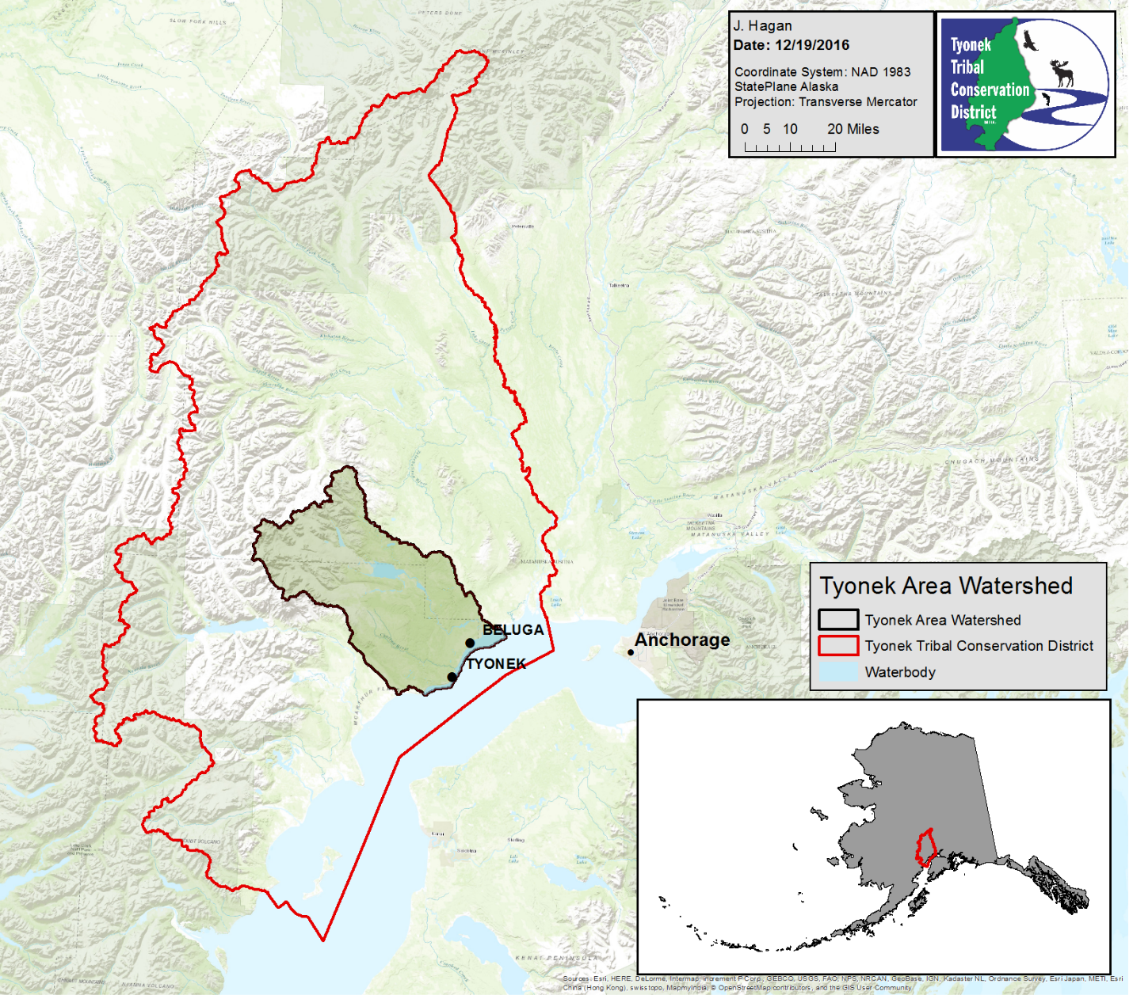

**Figure 2. Map of the Tyonek Area Watershed.**

Waterbodies with direct access to the Tyonek-Beluga road system are the most heavily used for sport and subsistence fishing activities. The Threemile Lake Complex, again defined for the purpose of this plan as East and West Threemile Lake and Lower Lily Pad Lake, has several access points including a motorized watercraft launch accessible by ATV, and is the most heavily used area for sport fishing activities in the region. The Threemile Creek watershed is a complex stream system covering 20.4 square miles. There are more than 20 inter-connected lakes and several more ephemeral lakes within the watershed. Due to the low-gradient landscape, flooding can connect closed lakes for periods of time and connect off-channel habitat and oxbows. The system is ground water dominated. Threemile Creek’s main stem runs between Threemile Lake and its mouth at Cook Inlet. Directly above Threemile Lake is Lower Lily Pad Lake and the confluence where West and East Fork Threemile Creek converge. West Fork Threemile Creek is significantly larger than East Fork Threemile Creek. The West Fork itself has two main branches, known as West Branch West Fork Threemile Creek and East Branch West Fork Threemile Creek (Figure 3). All forks and branches have smaller tributaries, sloughs and lakes.

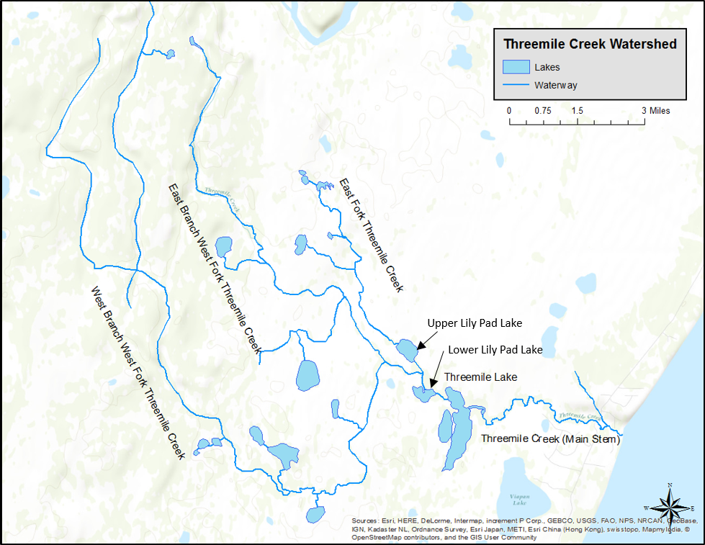

**Figure 3. Map of the Threemile Creek Drainage.**

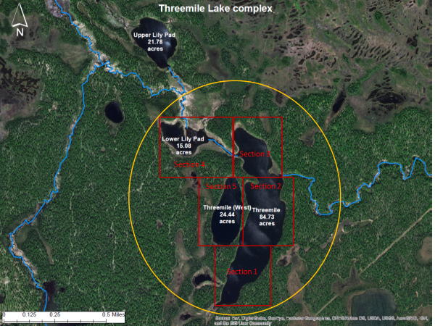

**Figure 4. Threemile Lake Complex delineated in yellow. Lake sections for the mark-recapture assessment are delineated in red (see Study Design section below).**

# Methods

## Background

The long-range goal of the partnership between TTCD, CIAA and ADF&G is to reduce the impact of invasive northern pike on rearing salmonids by removing as many northern pike from the Threemile Lake Complex as possible. Complete eradication of northern pike in the Threemile Creek Drainage would most likely be cost and logistically-prohibitive. However, relieving some of the predation pressure on salmon fry and smolt should increase their abundance by contributing to greater survival (Muhlfeld et al. 2008). Over time, greater survival of juvenile salmon may result in larger annual returns of adult salmon that support sport and subsistence fisheries in the TTCD. Increased salmon productivity in the Threemile drainage coupled with reductions in the northern pike population could eventually drive the fish community toward equilibrium. In other parts of Alaska where pike are native, and even in other drainages in Southcentral where they are not (i.e. the Deshka River), pike and salmonids are capable of coexisting; however, habitat complexity that allows salmonids opportunities for predator avoidance is hypothesized to be a strong factor in mediating predator-prey interactions within these fish communities (Sepulveda et al. 2013). In the Threemile Lake Complex, where the habitat is relatively homogenous providing ideal conditions for pike, salmonids are unable to avoid predation and, hence, their populations can drastically decline (Dunker et al. 2018). Through annual suppression of the northern pike population in this area, the partnership hopes to eventually restore salmonid production to sustainable levels in the Threemile Creek Drainage.

To effectively design and implement an annual northern pike suppression program in Threemile Lake, there are some useful first steps. It is prudent to begin with a baseline estimate on the size of the northern pike population (i.e. Baxter and Neufeld 2015). Estimating an initial population range will facilitate future evaluation of the suppression program because direct comparisons can be made between this initial baseline and pike population levels following periods of suppression. Further, the abundance estimate can be used to model annual removal targets to increase the effectiveness of the suppression program and determine, on an annual basis, if suppression activities are successfully meeting those targets.

ADF&G’s annual pike suppression program in Alexander Creek is on-going, but an initial population estimate was not available. While there are many favorable signs that the Alexander Creek northern pike suppression program is benefiting Chinook salmon production (Rutz and Dunker *In Prep*), direct quantitative conclusions are difficult in the absence of baseline data on the initial pike population size. Future invasive northern pike suppression programs will now aim to begin with this initial assessment when feasible. Further, unlike Alexander Creek at the onset of that suppression program, very little is currently known and documented about northern pike in the Threemile Lake Complex, except for the known association of pike presence and salmonid populations declining in the region (Swenson and Hagan 2017). In this pilot year, the partner agencies will conduct a mark-recapture study with the goal of estimating the population size of pike in the Threemile Lake Complex, collect biological data on sampled pike for future pike suppression modeling, and survey Upper Lily Pad Lake upstream of the Threemile Lake Complex to determine if pike are established there and document the current fish assemblage.

## Study Design

### Threemile Lake Northern Pike Population Estimate

This study is designed to estimate the abundance of northern pike within the Threemile Lake Complex (Figure 4, Appendix 1) using two-event Petersen mark-recapture techniques for a closed population (Seber 1982). Such techniques are designed to satisfy the following assumptions:

1. the population is closed (pike do not enter the population, via growth or immigration, or leave the population, via death or emigration, during the experiment);
2. all pike will have a similar probability of capture during the first event or during the second event, or marked and unmarked pike will mix completely between events;
3. marking of pike will not affect the probability of capture during the second event;
4. marked pike will be identifiable during the second event; and,
5. all marked pike will be reported when recovered in the second event.

Failure to satisfy these assumptions may result in biased estimates; therefore, the study is designed to ensure these assumptions are reasonably valid.

*Sampling*

Fyke nets or metal screening will be deployed in the inlets and outlets of the Threemile Lake Complex to prevent immigration and emigration of pike during the study and ensure that Assumption 1 is not violated. The mark event will take place between 1 June and 10 June. At least four anglers will use hook and line gear and two crew members will deploy and monitor gillnets to sample pike for 8 hours each day over the course of 10 days during both the mark and the recapture events. Fyke net locations will remain the same for both events and will be checked periodically each day to make sure they are effectively blocking access. To aid in the evaluation of assumptions and ensure sampling effort is uniformly distributed, the lake complex has been divided into 5 sections (Figure 4). During each event, the 4-person angling crew and the 2-person gillnetting crew will fish one section per day. Gillnetting and angling efforts will start on opposite ends of each lake section to ensure sampling efforts do not interfere with each other. Angling efforts will proceed systematically from one end of the complex to the other. After crews have fished the entire complex, they will return to the section they started in and make a second pass of the entire complex so that each of the five sections is sampled twice during each 10-day event.

A 2-person crew will set up to 10 gillnets in each section along the littoral zone at the beginning of the day’s sampling period. Nets will be distributed uniformly in the littoral zone of each section, and locations will be recorded with GPS for repeatability. Throughout the sampling period, the crew will continuously boat along the nets and remove any pike that are captured. If it takes greater than 30 minutes between checking nets or the pike in the nets appear impaired from time spent in the nets, some of the gillnets may be removed to reduce capture or handling mortality. Captured pike will be measured for fork length (FL; mm) and all individuals ≥ 300 mm FL will be tagged with an individually numbered Floy T-bar tag and released where they were caught. T-bar tags will be inserted through the proximal pterygiophore at the mid-length of the dorsal fin. A left pelvic fin clip will serve as a secondary mark to control for tag loss. For the mark event, the gillnets will be removed at the end of each day’s sampling period to avoid over-night mortality. While the gillnetting effort each day is underway, 4 anglers will fish in the same lake section as the gillnetters for the 8-hour sampling period. Two anglers will fish from an inflatable boat and 2 anglers will fish from shore. Anglers will work their way through each section in a systematic manner to ensure efforts are distributed uniformly across the lake. For instance, at the start of each day, anglers will begin at the southernmost part of each section and will position themselves relatively equidistant from each other (2 on opposite shorelines, and 2 in the middle of the section in inflatables). After a period of 15 minutes without catching a fish, anglers will be instructed to move northward about 20 meters to begin fishing a new fishing location. Otherwise, they will stay in the same location until catch rates slow to less than 1 pike per 15 minutes. Once anglers reach the opposite end of their lake section, they will continue repeating each transect until the fishing period for the day ends. A combination of pike lures with single hooks will be used, but the hooks will either be barbless or the barbs will be flattened to minimize injuries during capture. Time spent fishing will be recorded for each angler. The same employed for gillnetted pike will also be used for all fish captured during hook and line sampling. A 10-day hiatus interval will separate the mark event from the recapture event. Mixing of tagged and untagged individuals should occur within this timeframe but will be tested for during data analysis.

The recapture event will take place between 21 June and 30 June. All fish will be killed during this event, and thus, the recapture event will serve as the first opportunity to begin suppression of the pike population in the Threemile Lake Complex. Though the recapture event will allow for opportunistic suppression during this project, a formal suppression plan for future years will be developed after this current project concludes. All pike in the recapture event will be immediately dispatched, tagged with the capture location, and put in a cooler for later processing. Methods for capturing fish during the recapture will be the same as those used during the mark event with the following exceptions: gillnets will be allowed to fish through the evening and be moved the next morning to the new lake section, and the fyke nets will be fished concurrently with the gillnets. Up to 20 gillnets may be used during the recapture event. This increased fishing time is permitted during the recapture because mortality of captured pike will no longer be a concern and because pike will likely be moving less due to increased water temperatures and cessation of spawning activities. Therefore, increased sampling effort will be necessary during the recapture event. When each day’s 8-hour fishing period ends, project staff will measure each pike for fork length and weight, remove the cleithrum for ageing, and dissect each pike to document stomach contents and sex. These data will be recorded in data sheets (Appendix 5). If more than 6 people are available during the recapture event, additional staff will be allocated to processing these fish throughout each day.

### Evaluation of Assumptions

**Assumption 1:** Assumption 1 will likely not be violated because inlets and outlets of the Threemile Lake Complex will functionally be blocked off with fyke nets during this study. In addition, this study will be of short duration, and therefore, growth recruitment and mortality will be insignificant. Also, if during the mark event, pike are mortally injured (i.e. hook through the eye, bleeding gills, etc.) or seem unusually stressed, the fish will be sacrificed rather than marked.

**Assumption 2:** We do not have evidence to suggest pike will mix completely during the 10-day hiatus. Therefore, Assumption 2 will be met by attempting to subject all fish to the same probability of capture during each sampling event. While angling and fishing with gillnets, fishing effort will be distributed in proportion to the distribution of pike. Based on catch rates and visual observations, effort will be increased in areas where densities appear relatively high (e.g., shallow vegetated bays and outlet areas) and decreased where there appear to be few fish available (e.g., deep water zones). Sample sizes are expected to be large enough to provide sufficient power for tests of heterogenous capture probabilities. Differences in capture probability related to fish size, sex, and location will be tested for as described in Appendix 4. If significant differences are detected, stratified estimates of abundance and its variance will be used.

**Assumption 3**: The hiatus between mark and recapture events should allow marked fish to recover from the effects of handling and marking during the first event; therefore, Assumption 3 should be valid. However, it is unknown if fish captured in gillnets during the mark event will avoid this gear during the recapture event, but the heavy use of hook and line sampling should mitigate such an effect if it exists.

**Assumption 4:** This assumption will be addressed by double-marking each pike captured during the first event. Tag loss will be noted when a fish is recovered during the second event with a first-event fin clip but without a FloyTM tag. In addition, tag placement will be standardized, which will enable the fish handler to verify tag loss by locating recent tag wounds.

**Assumption 5:** All fish will be thoroughly examined for tags or recent fin clips. All markings (tag number, tag color, fin clip, and tag wound) for each fish will be recorded.

*Sample Size*

As stated previously, the abundance estimate for pike in the Threemile Lake Complex established through this study will be used to model future pike suppression goals. This estimate will also serve as the baseline from which the pike suppression activities can be evaluated for their effectiveness. Since no previous estimates of abundance are available, a range of possible population sizes will be used to calculate the sample size required to meet the precision criteria. According to broad estimates, there are roughly 7,000 to 10,000 pike present in the Threemile Lake Complex (Andy Wizik, CIAA, personal communication). Since this is a rough guess, we will calculate necessary sample sizes for populations ranging from 5,000 to 15,000 fish. If there are 5,000 fish present, 437 fish will need to be sampled during each sampling occasion to meet the precision criteria of objective 1 (Robson and Regier 1964). If there are 15,000 fish present, 785 fish will need to be sampled during each sampling occasion.

An educated guess of the sample sizes we can expect to obtain incorporates previous catch rates of pike in Threemile Lake, and the available man power and allotted time for the project. In past investigations, it was possible to catch at least 1 pike per angler hour in Threemile Lake, and CPUE with gillnets was approximately 1 pike per net hour (Swenson and Hagan 2017). Assuming this experience remains the same for this study, 4 people fishing for 10 days each and catching pike at the rate of 1 pike per hour for 8 hours per day, will yield approximately 320 fish. A gillnetting crew fishing 10 gillnets for 8-hour sets per day for 10 days at a rate of 1 pike per net hour are likely to catch approximately 800 pike. Given these values, an anticipated sample size of up to 1,120 individuals/sample occasion is possible.

### Upper Lily Pad Lake Northern Pike Survey

Past investigations of pike in Upper Lily Pad Lake did not physically catch any pike, although their presence is suspected and they are present in the stream connection between Upper and Lower Lily Pad Lakes (Swenson and Hagan 2017). Further, no salmonids were discovered during these investigations despite records for them in the Anadromous Waters Catalog (AWC). It is beneficial to confirm the presence of pike in this lake due to its proximity to other lakes in the complex. Given the inability to catch a pike there previously, it is unlikely the population is prolific. However, if a well-established pike population is found and previously observed native fish species are in low abundance, expanding future pike suppression plans to include Upper Lily Pad Lake will be warranted. Gillnets are frequently used for the detection and suppression of invasive northern pike in Alaska (Rutz et al., *In Prep*, Glick and Willette 2016, Sepulveda 2013). Gillnets are most effective when fished in optimal habitat conditions for northern pike which typically include sloughs and the shallow bays, embankments, and densely-vegetated littoral zones of lakes (Inskip 1982).

#### Sampling Effort for Surveying Upper Lily Pad Lake

To quantify the netting effort necessary to detect if northern pike are established in Upper Lily Pad Lake (Appendix 2), a method used for past projects was employed (Massengill *In Prep*) that originated from pike removal estimates for lakes on the Kenai Peninsula (Appendix 3).

For this investigation, during the hiatus between the mark and recapture events in the Threemile Lake Complex, 11 gillnets will be deployed in Upper Lily Pad Lake. To obtain a probability of non-detection of ~2%, Upper Lilly Pad Lake will need to be sampled for 4 days, unless a pike is captured before then (Table 1).

Table .– Probabilities of not detecting a small northern pike population (N=4) in Upper Lily Pad Lake for up to 4 days of netting with 0.5 nets per littoral surface acre (~22 acres, so 11 nets).

|  |  |
| --- | --- |
|  | **Upper Lily Pad Lake** |
| **Littoral Acreage** | 22 |
| **Nets** | 11 |
| **Hours** | **Probability of Non-Detection** |
| 24 | 0.39 |
| 48 | 0.15 |
| 72 | 0.06 |
| 96 | 0.02 |

Upper Lily Pad Lake will be sampled with one 2-person field crew. Gillnets will be deployed in the vegetated littoral zone and fished continuously until a pike is captured, or up to 4 days if a pike is not captured. The field crew will be present at the lake every day to check the nets, collect and record data, and free any bycatch. GPS coordinates will be collected at all net locations. If and when northern pike are captured, the netting strategy will be altered because pike presence will have been confirmed. At this time, gillnets will remain in place for 48 hours and serve to calculate CPUE of pike and other fish to characterize the fish assemblages in the lakes. Forty-eight hours after catching the first pike, the nets will be removed to avoid unnecessary bycatch. If no pike are captured during this netting assessment, it will be determined that the pike population in Upper Lily Pad Lake is not large enough to warrant future suppression activities. During the gillnetting assessment of Upper Lily Pad Lake, the netting crew also deploy 2 gillnets in the stream connecting Upper and Lower Lily Pad Lakes for a 24-hour period to measure CPUE. Minnow traps will also be deployed in the creek at this time to document if juvenile salmonids are present.

## Data Collection

### Threemile Lake Northern Pike Population Estimate

All data and daily summaries will be recorded in “Rite-in-the-Rain®” notebooks following the format in Appendix 5. For each fish caught, its fork length, tag number and tag color, and fin clip will be recorded in the notebook. All captured pike will be measured to the nearest mm FL. Any mark-event pike that die during handling and all recapture-event pike will be processed for fork lengths, weight, age (by counting annuli on cleithra bones), sex, and stomach contents. All data will be recorded on data sheets (Appendix 5). Also, any pike < 300mm FL will dispatched and processed in the same manner. Each crew member will also keep a daily field journal in a “Rite-in-the-Rain®” notebook. An important goal in recording the information below is to identify conditions that may have a substantial effect on the probability of capture during a sampling event. Information collected should include:

1. Gear type that was most effective and at which times it was most effective.
2. Weather and water conditions (e.g., cloud cover, precipitation, temperature, water level, and clarity);
3. Net set and pull times;
4. Hours worked each day by each crew member;
5. Number of fish captured, number of mortalities.

### Pike Population Characteristics

As previously stated, during the recapture event, additional data will also be collected for each of the captured pike. All pike removed during this event will be immediately dispatched and placed in a cooler for later processing of fork lengths, weight, age, sex, and stomach contents. All data will be recorded on data sheets (Appendix 5).

### Upper Lily Pad Lake Northern Pike Survey

All fish captured in gillnets will be counted and identified to species. Catch of all species other than northern pike will be recorded on data sheets (Appendix 5), and all fish other than northern pike will be released immediately. The fork lengths of all captured northern pike will be measured and recorded to the nearest millimeter. All captured pike will be dispatched on-site and their sex, maturity, and stomach contents will be recorded.

## Data Reduction

Data will be transferred from field notebooks and data sheets to Microsoft Excel worksheets for analysis. Column headings of the worksheet will include: sample number, date of capture, event number, tag number, tag color, gear type, fin clip, and field comments. Each fish will have a unique sample number, but to avoid duplication with other crew members in the field, crew will number their fish with their initials and numbers from 1….n (i.e. KD1, KD2,….KDn). Then during data entry, a column will be added to the file to provide a unique number from 1….n for each fish. In addition, a column will be created to document whether a fish captured during the second event was a recapture. For the recapture event, or fish captured during the mark event that were either injured or too small, additional data for length, sex, maturity, and stomach contents will also be entered into the Excel worksheet. Additional comments may be added for clarity and a glossary of all column headings will be provided as metadata with brief descriptions. Final copies of the Excel files will be provided with the completed report when it is submitted for review to be archived in the Sport Fish Division Docushare repository. At that time, a file name and directory will be assigned, which will be included as an appendix in the final report.

## Data Analysis

### Threemile Lake Northern Pike Population Estimate

*Abundance*

Abundance and its variance will be estimated with the Chapman’s modification of the Petersen estimator:

$$\hat{N}=\frac{\left(n_{1}+1\right)\left(n_{2}+1\right)}{\left(m_{2}+1\right)}-1$$

$$\hat{V}\left(\hat{N}\right)=\frac{\left(n_{1}+1\right)\left(n_{2}+1\right)\left(n_{1}-m_{2}\right)\left(n_{2}-m_{2}\right)}{{\left(m_{2}+1\right)}^{2}\left(m_{2}+2\right)}$$

where:

$n_{1}$ = the number of fish marked during the first sampling event;

$n_{2}$ = the number of fish examined during the second sampling event; and,

$m_{2}$ = the number of fish captured during the second event with marks from the first event.

If tests indicate heterogenous capture probabilities related to size, length, or location, a stratified estimate of abundance and its variance will be used (Appendix 4).Also, a histogram of pike captured by length category will be generated for the Threemile Lake Complex.

### Upper Lily Pad Lake Northern Pike Survey

If northern pike are detected in multiple age classes or are numerous, their establishment in the lake will be confirmed. If northern pike are not detected within 4 days of gillnetting, the conclusion will be made that either no northern pike are in the lake or that there is a population of less than 4 northern pike in the lake (probability of non-detection error < 0.02).

# Schedule and Deliverables

|  |  |
| --- | --- |
| May 2018: | Purchase equipment and field camp gear Confirm field crews  Transfer equipment |
| June 1-10: | Mark Event |
| June 11-20: | Upper Lily Pad Lake assessment |
| June 21-30: | Recapture Event  Collect size, gender, maturity, and diet data |
| July 2018: | Data entry |
| Aug. 2018: | Analyze data and write project report  Model future pike suppression targets |

RESPONSIBILITIES

Personnel: Kristine Dunker, Fishery Biologist III, Alaska Department of Fish and Game, Sport Fish Division

Duties: Provide oversight and make recommendations on study designs and project plans; assist with data analysis and project reporting; coordinate and assist with the completion of project deliverables.

Personnel: Parker Bradley, Fishery Biologist II, Alaska Department of Fish and Game, Sport Fish Division.

Duties: Serve as the primary project biologist; assist with planning and coordinating field logistics; Assist with project reporting and presentations to the public.

Personnel: Cody Jacobson, Fishery Biologist I, Alaska Department of Fish and Game, Sport Fish Division.

Duties: Assist with planning and coordinating field logistics and equipment procurement; Supervise field activities and technicians

Personnel: Ben Buzzee, Biometrician IV, Alaska Department of Fish and Game, Sport Fish Division.

Duties: Provide guidance on study design; Assist with post-season data analysis. Review project operational plans and reports.

Personnel: Nicole Swenson, Biologist, Tyonek Tribal Conservation District.

Duties: Provide guidance on study design; Coordinate field logistics and equipment procurement.

Personnel: Andy Wizik, Biologist, Cook Inlet Aquaculture Association.

Duties: Provide guidance on study design; field assistance and equipment procurement.

In addition, four fish and wildlife technicians will be hired to assist with the field activities.

# Literature Cited

Alaska Department of Fish and Game. 2002. Aquatic Nuisance Species Management Plan. Alaska Department of Fish and Game. 55 pp.

Alaska Department of Fish and Game. 2007. Management Plan for Invasive Northern Pike in Alaska. Alaska Department of Fish and Game, Division of Sport Fish, Anchorage. 64 pp.

Conover, W. J. 1980. Practical nonparametric statistics 2nd ed. John Wiley & Sons, New York.

Baxter, J.T. and M. Neufeld. 2015. Lower Columbia River Northern Pike Suppression and Stomach Analysis – 2014. Final Report to Teck Trail Operations, British Columbia Ministry of Forests, Lands, and Natural Resource Operations, 28 pp.

Dunker, K., A. Sepulveda, R. Massengill, and D. Rutz. 2018. [The northern pike, a prized native but disastrous invasive.](https://www.crcpress.com/Biology-and-Ecology-of-Pike/Nilsson-Skov/p/book/9781482262902) Pages 356-398 [In] C. Skov and P. A. Nilsson, editors. Biology and ecology of pike. CRC Press, Boca Raton, FL.

Glick, W.J. and T.M. Willette. 2016. Relative abundance, food habits, age, and growth of northern pike in 5 Susitna River drainage lakes, 2009-2012. AK Dept. of Fish and Game, FDS No. 16-34, Anchorage.

Inskip, P. D. 1982. Habitat suitability model: northern pike. U.S. Department of Interior, Fish and Wildlife Service, FWS/OBS-82/10.17. 40pp.

C., Jacobson, K. Dunker and D. Rutz. 2016. Northern Pike Eradication in the Cottonwood Creek Drainage – Phase 1. Alaska Department of Fish and Game, Regional Operational Plan ROP.DF#R. YY-17, Anchorage.

Jones, B., D. Holen, and D. S. Koster. 2015. The harvest and use of wild resources in Tyonek, Alaska, 2013. Alaska

Department of Fish and Game Division of Subsistence, Technical Paper No. 404. Anchorage.

Massengill, R. L. 2010. Control efforts for invasive northern pike on the Kenai Peninsula, 2005-2006. Alaska Department of Fish and Game, Fishery Data Series No. 10-05, Anchorage.

Mills, M. J. 1986. Alaska statewide sport fish harvest studies - 1985 data. Alaska Department of Fish and Game, Federal Aid in Fish Restoration and Anadromous Fish Studies, Annual Performance Report 1985-1986, Project F-10-1, 27 (RT-2), Juneau.

Muhlfeld, C.C., D.H. Bennet, R.K. Steinhorst, B.Marotz, and M. Boyer. 2008. Using Bioenergetics Modeling to Estimate Consumption of Native Juvenile Salmonids by Nonnative Northern Pike in the upper Flathead River System, Montana. North American Journal of Fisheries Management 28: 636-648.

Robson, D. S. and H. A. Regier. 1964. Sample size in Peterson mark-recapture experiments. Transactions

of the American Fisheries Society 93:215-226.

Seber, G. A. F. 1982. The estimation of animal abundance and related parameters, second edition. Charles Griffin and Co., Ltd. London, U.K.

Rutz, D. S and K.J. Dunker. *In Prep*. Alexander Creek Northern Pike Suppression 2011-2016. Alaska Department of Fish and Game, Fishery Data Series Report No. XX-XX. Anchorage.

Sepulveda, A.J., D.S. Rutz, S.S. Ivey, K.J. Dunker and J.A. Gross. 2013. Introduced northern pike predation on salmonids in southcentral Alaska. Ecology of Freshwater Fish 22(2): 268-279

Sepulveda, A.J., D.S. Rutz, A.W. Dupuis, P.A. Shields and K.J. Dunker. 2014. Introduced northern pike consumption of salmonids in Southcentral Alaska. *Ecol. Freshwater Fish*. DOI: 10.1111/eff.12164.

Swenson, N. and J. Hagan, 2017. Invasive Northern Pike (Esox lucius) in the Tynoek Tribal Conservation District Field Methods. Report. 22 pp.

# 

APPENDICES

**Appendix 1**. **Photograph of the boat launch at Threemile Lake**

**

**Appendix 2. Photograph of Upper Lilly Pad Lake**



**Appendix 3. Calculating the probability of detecting northern pike with gillnetting efforts.**

Between 2005 and 2010, ADF&G conducted 12 removal experiments with northern pike populations on the Kenai Peninsula using similar sampling methods. Data collected from these experiments included catch $C_{ij}$ and effort $E_{ij}$ (in units of net-hours per surface acre) for sample $i (i=1, …, s)$ and experiment $j \left(j=1, …, 12\right).$ Populations are assumed to be closed except for fish caught and the fishing is assumed to represent a Poisson process with a constant probability of capture for all individuals. Data was analyzed using a hierarchical version of Leslie’s regression method (Seber 1982):

$${CPUE}_{ij} = K_{j}N_{j} - K_{j}C_{ij}^{*}$$

where:

$${CPUE}_{ij}= {C_{ij}}/{E_{ij}}$$

$$C_{ij}^{*} = \sum_{k=1}^{i-1}{C_{kj}} for \left(i in 2, …, s+1\right) with C_{1j}^{*}=0$$

$N_{j}$ = the initial population size in experiment j

$K_{j}$ = average probability that a fish is captured with one unit of effort during experiment j,

The probabilities of capture for each experiment are assumed to come from a common distribution:

$$K_{j} \sim beta\left(a, b\right)$$

The analysis was conducted using the RJAGS package (Plumber 2013) within R (R Core Team 2016). Non-informative priors were used for all parameters. Although Leslie’s method is typically used to estimate the initial population size our interest was in the posterior and predictive distributions of $K$ for the purpose of estimating the probability of detecting small pike populations in future removal experiments.

Percentiles from the predictive distribution for the value of *K* in a new removal experiment are shown in Table 1 and the predictive distribution is shown in Figure 1.

**Table 1: Percentiles from the predictive distribution of *K*.**

|  |  |
| --- | --- |
| Percentile | predicted *K* |
| 5% | 0.001 |
| 10% | 0.003 |
| median | 0.019 |
| 90% | 0.055 |
| 95% | 0.073 |

**Appendix 3. page 2 of 3**

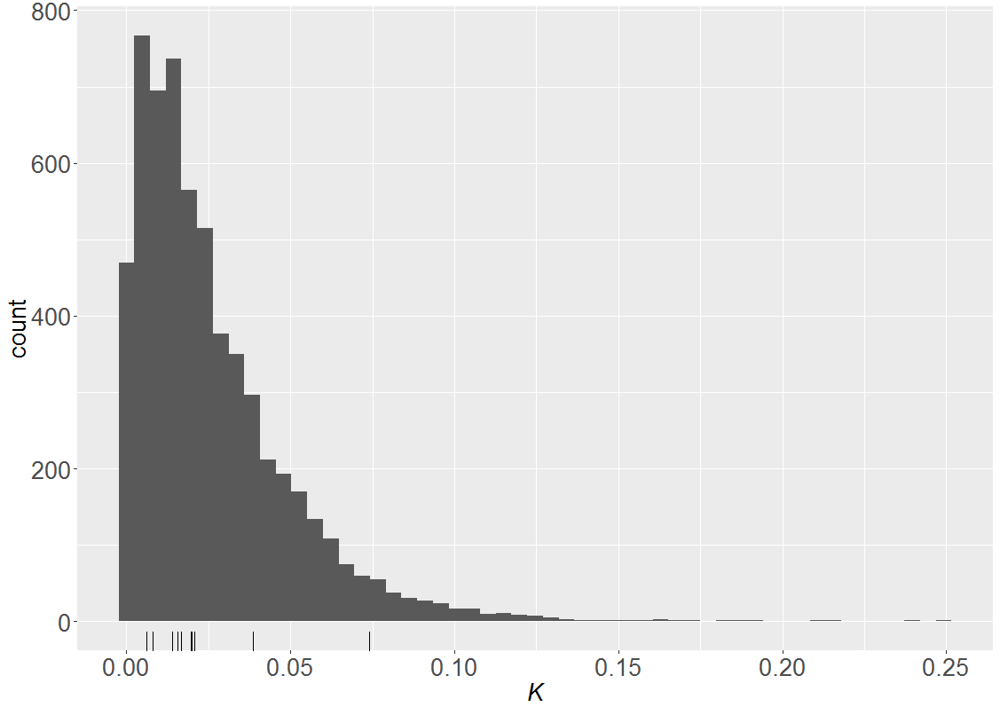

**Figure 1: Prediction distribution for *K, the average probability a fish is captured in a new removal experiment with one unit of effort. Tick marks along the x-axis show the median values for Kj, the average probability a fish is captured with one unit of effort in each of the previous removal experiments.***

Under the assumption that fishing represents a Poisson counting process, the probability of failing to detect a population of pike of size N as a function of net-hours per acre (E) is:

$D_{p}=$ = ${exp⁡(-KE)}^{N}$

We will use the median value of K from Table 1 to calculate probabilities. The value of effort will be chosen based on logistical considerations such as the number of nets and technicians available.

**Table 2: Probability of failing to detect a population of 4 pike with various levels of netting effort.**

|  | **Net Densities** | | | | | |
| --- | --- | --- | --- | --- | --- | --- |
|  | **0.1nets/sa** | **0.25nets/sa** | **0.5nets/sa** | **0.75nets/sa** | **1nets/sa** | **2nets/sa** |
| **24 hours** | 0.829 | 0.626 | 0.392 | 0.246 | 0.154 | 0.024 |
| **48 hours** | 0.688 | 0.392 | 0.154 | 0.060 | 0.024 | 0.001 |
| **72 hours** | 0.570 | 0.246 | 0.060 | 0.015 | 0.004 | 0.000 |
| **96 hours** | 0.473 | 0.154 | 0.024 | 0.004 | 0.001 | 0.000 |

**Appendix 4a.–Detection and mitigation of selective sampling during a two-event mark recapture experiment.**

Size- and sex-selective sampling may cause bias in two-event mark-recapture estimates of abundance and size and sex composition. Kolmogorov-Smirnov (KS) two sample tests are used to detect size-selective sampling and contingency table analyses (Chi-square tests of independence) are used to detect evidence of sex-selective sampling.

Results of the KS and Chi-square tests will dictate whether the data needs to be stratified to obtain an unbiased estimate of abundance. The nature of the detected selectivity will also determine whether the first, second, or both event samples are used for estimating size and sex compositions.

Definitions

M = Lengths or sex of fish marked in the first event

C = Lengths or sex of fish inspected for marks in the second event

R = Lengths or sex of fish marked in the first event and recaptured in the second event

Size-Selective Sampling: KS Tests

Three KS tests are used to test for size-selective sampling.

|  |  |  |
| --- | --- | --- |
| KSTest 1 | C vs R | Used to detect size selectivity during the 1st sampling event.  Ho: Length distributions of populations associated with C and R are equal |
| KSTest 2 | M vs R | Used to detect size selectivity during the 2nd sampling event.  Ho: Length distributions of populations associated with M and R are equal |
| KSTest 3 | M vs C | Used to corroborate the results of the first two tests.  Ho: Length distributions of populations associated with M and C are equal |

Sex-Selective Sampling: Chi-Square **Tests**

Three contingency table analyses (χ2-tests on 2x2 tables) are used to test for sex-selective sampling.

|  |  |  |
| --- | --- | --- |
| χ2 Test 1 | C vs R | Used to detect sex selectivity during the 1st sampling event.  Ho: Sex is independent of the C - R classification |
| χ2 Test 2 | M vs R | Used to detect sex selectivity during the 2nd sampling event.  Ho: Sex is independent of the M - R classification |
| χ2 Test 3 | M vs C | Used to corroborate the results of the first two tests.  Ho: Sex is independent of the M - C classification |

Table A1 presents possible results of selectivity testing, their interpretation, and prescribed action.

Appendix 4a.–Page 2 of 3.

Table A1.–Possible results of selectivity testing, interpretation and action.

|  |  |  |  |  |
| --- | --- | --- | --- | --- |
|  | KS or χ2 Test | | |  |
| Case | M vs. R  (2nd event test) | C vs. R (1st event test) | M vs. C (1st vs 2nd event) | Interpretation and Action |
| I | Fail to reject Ho | Fail to reject Ho | Fail to reject Ho | Interpretation: No selectivity during either sampling event.  Action:  Abundance: Use a Petersen-type model without stratification.  Composition: Use all data from both sampling events. |
| II | Reject Ho | Fail to reject Ho | Reject Ho | Interpretation: No selectivity during the 1st event but there is selectivity during the 2nd event.  Action:  Abundance: Use a Petersen-type model without stratification.  Composition: Use data from the 1st sampling event without stratification. 2nd event data only used if stratification of the abundance estimate is performed, with weighting according to Equations 1-3 below. |
| III | Fail to reject Ho | Reject Ho | Reject Ho | Interpretation: No selectivity during the 2nd  event but there is selectivity during the 1st event.  Action:  Abundance: Use a Petersen-type model without stratification.  Composition: Use data from the 2nd sampling event without stratification. 1st event data may be incorporated into composition estimation only after stratification of the abundance estimate and appropriate weighting according to Equations 1-3 below. |
| IV | Reject Ho | Reject Ho | Either result | Interpretation: Selectivity during both 1st and 2nd events.  Action:  Abundance: Use a stratified Petersen-type model, with estimates calculated separately for each stratum. Sum stratum estimates for overall abundance.  Composition: Combine stratum estimates according to Equations 1-3 below. |
| V | Fail to reject Ho | Fail to reject Ho | Reject Ho | Interpretation: The results of the 3 tests are inconsistent.  Action: Need to determine which of Cases I-IV best fits the data. Inconsistency can arise from high power of the M vs. C test or low power of the tests involving R. Examine sample sizes (generally M or C from <100 fish and R from <30 are considered small), magnitude of the test statistics (Dmax), and the *P*-values of the three tests to determine which of which of Cases I-IV best fits the data. |

Appendix 4a.–Page 3 of 3.

**Composition estimation for stratified estimates**

An estimate of the proportion of the population in the *kth*size or sex category for stratified data with *I* strata is calculated as follows:

, (1)

with variance estimated as

, (2)

where

|  |  |
| --- | --- |
| = | estimated proportion of fish belonging to category *k* in stratum *i*; |
| = | estimated abundance in stratum *i*; and |
| = | estimated total abundance |
|  | =. (3) |

**Appendix 4b.–Tests of consistency for the Petersen estimator (from Seber 1982, page 438).**

**Tests of Consistency for Petersen Estimator**

Three contingency table analyses are used to determine if the Petersen estimate can be used (Seber 1982). If any of the null hypotheses are not rejected, then a Petersen estimator may be used. If all three of the null hypotheses are rejected, a temporally or spatially-stratified estimator (Darroch 1961) should be used to estimate abundance.

Seber (1982) describes 4 conditions that lead to an unbiased Petersen estimate, some of which can be tested directly:

1. Marked fish mix completely with unmarked fish between events.
2. Equal probability of capture in event 1 and equal movement patterns of marked and unmarked fish.
3. Equal probability of capture in event 2
4. The expected number of marked fish in recapture strata is proportional to the number of unmarked fish.

In the following tables, the terminology of Seber (1982) is followed, where *a*represents fish marked in the first event, *n* fish captured in second event and *m* marked fish recaptured; *m•j* and *mi•* represent summation over the *ith* and *jth* indices, respectively.

1. **Mixing Test**

Tests the hypothesis (condition 1) that movement probabilities (θ*ij*), describing the probability that a fish moves from marking stratum *i* to recapture stratum *j*, are independent of marking stratum: H0: θ*ij* = θ*j* for all *i* and *j*.

|  |  |  |  |  |  |
| --- | --- | --- | --- | --- | --- |
| Area/Time Marking Strata *(i)* | Area/Time Recapture Strata *(j)* | | | | Not Recaptured *ai – mi•* |
| 1 | 2 | … | t |
| 1 | *m11* | *m12* | *…* | *m1t* | *a1 – m1•* |
| 2 | *m21* | *m22* | *…* | *m2t* | *a2 – m2•* |
| *…* | *…* | *…* | *…* | *…* | … |
| s | *ms1* | *ms2* | *…* | *mst* | *as – ms•* |

1. **Equal Proportions Testa (SPASb terminology)**

Tests the hypothesis (condition 4) that the marked to unmarked ratio among recapture strata is constant: H0: Σ*ai*θ*ij /Uj* = *k,* where *k* = a constant, *Uj* = unmarked fish in stratum *j* at the time of 2nd event sampling, and *ai* = number of marked fish released in stratum *i*. Failure to reject H0 means the Petersen estimator should be used only if the degree of closure among tagging strata is constant, i.e. Σ*j*θ*ij* = λ (Schwarz and Taylor 1998; p 289). A special case of closure is when all recapture strata are sampled, such as in a fishwheel to fishwheel experiment, where Σ*j*θ*ij* = 1.0; otherwise biological and experimental design information should be used to assess the degree of closure.

|  |  |  |  |  |
| --- | --- | --- | --- | --- |
|  | Area/Time Recapture Strata *(j)* | | | |
|  | 1 | 2 | … | t |
| Recaptured (*m.j*) | *m•1* | *m•2* | … | *m•t* |
| Unmarked (*nj - m.j*) | *n1 - m•1* | *n2 - m•2* | … | *nt - m•t* |

Appendix 4b.–Page 2 of 2.

1. **Complete Mixing Testa (SPASb terminology)**

Tests the hypothesis that the probability of re-sighting a released animal is independent of its stratum of origin: H0: *Σjθijpj = d*, where *pj* is the probability of capturing a fish in recapture stratum *j* during the second event, and *d* is a constant.

|  |  |  |  |  |
| --- | --- | --- | --- | --- |
|  | Area/Time Marking Strata *(i)* | | | |
|  | 1 | 2 | … | s |
| Recaptured (*mi*) | *m1•* | *m2•* | … | *ms•* |
| Not Recaptured (*ai - mi•*) | *a1 - m1•* | *a2 - m2•* | … | *as - ms•* |

a There is no 1:1 correspondence between Tests II and III and conditions 2-3 above. It is pointed out that equal probability of capture in event 1 will lead to (expected) non-significant Test II results, as will mixing, and that equal probability of capture in event 2 along with equal closure (Σjθij = λ) will also lead to (expected) non-significant Test III results.

b Stratified Population Analysis System (Arnason, A.N., C.W. Kirby,C.J. Schwarz and J.R. Irvine. 1996. Computer Analysis of Data from Stratified Mark-Recovery Experiments for Estimation of Salmon Escapements and Other Populations, Canadian Technical Report of Fisheries and Aquatic Sciences 2106.

**Appendix 5. Data Sheets**



